Fibonacci Cubes－A New Interconnection Topology
Wen-Jing Hsu
IEEE Transactions on Parallel and Distributed System, Vol. 4, No. 1, pp. 3~12, January 1993
Abstract
In spite of its asymmetric and relatively sparse interconnections, the Fibonacci cube is shown to possess attractive recurrent structures. Since it can be embedded as a subgraph in the Boolean cube and it is also a supergraph of other structures, the Fibonacci cube may find applications in fault-tolerant computing.
- Introduction
Fibonacci number:
- Definitions
Fibonacci cubes:
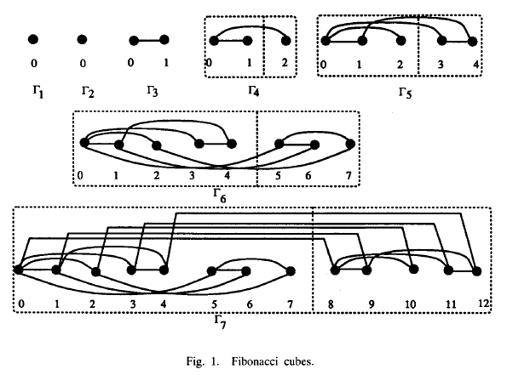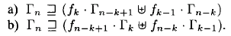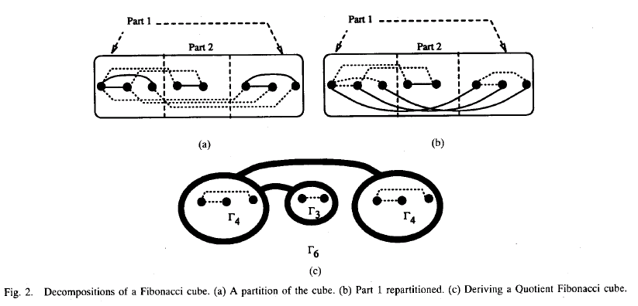
- Topological Properties of Fibonacci Cubes
# of edges:
- Embedding of Other Structures
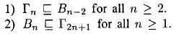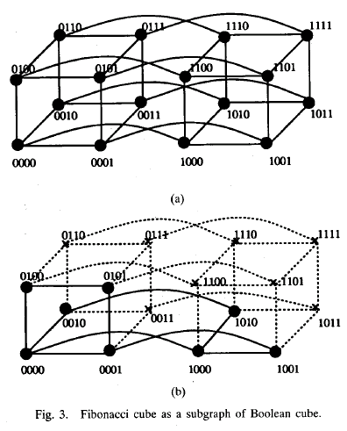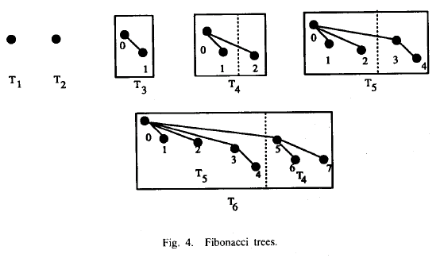
- Communication Primitives
Simple Send: n-2 steps
Single node broadcast and Single node accumulation can be done in O(logN) time; Single node gather, Single node scatter, Multiple node broadcast, and Multinode accumulation can all be done in O(N) time; moreover, the Total Exchange operation can be done in O(NlogN) time.(N:fn)
- Discussion and Conclusion

Created by: Chia-Mao Huang
Date: Mar. 3, 2000

